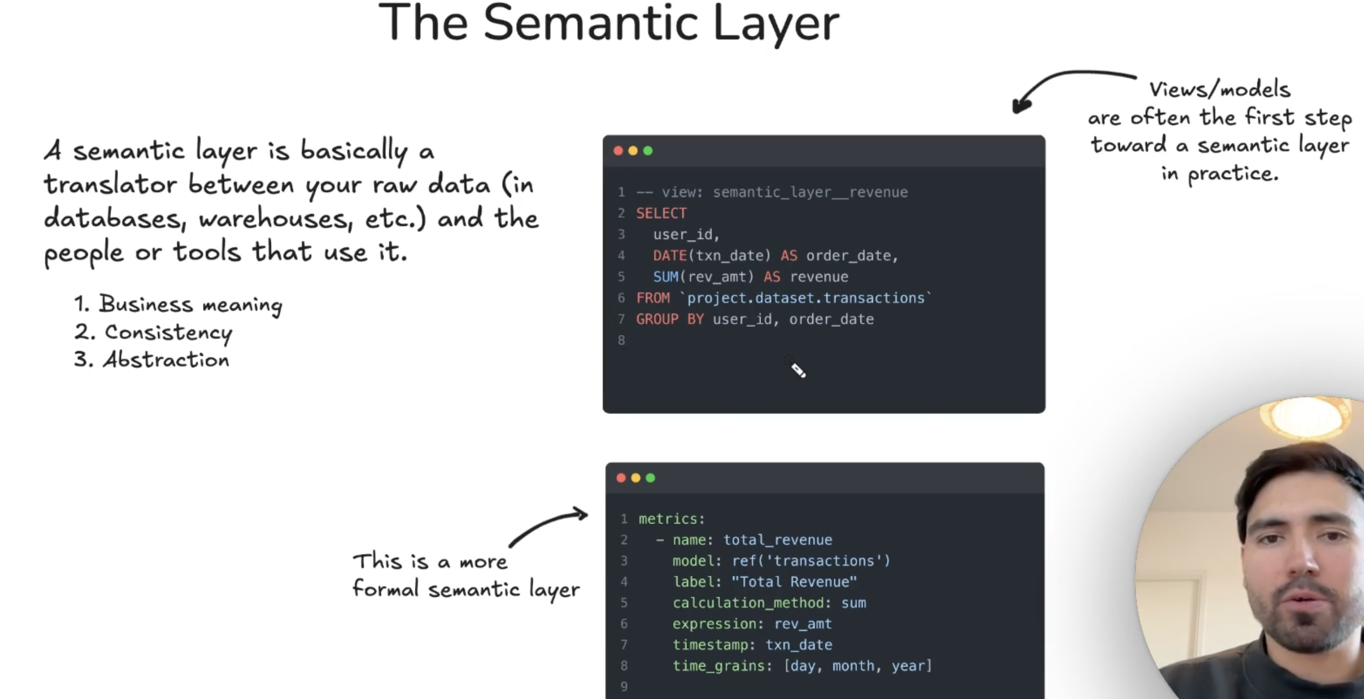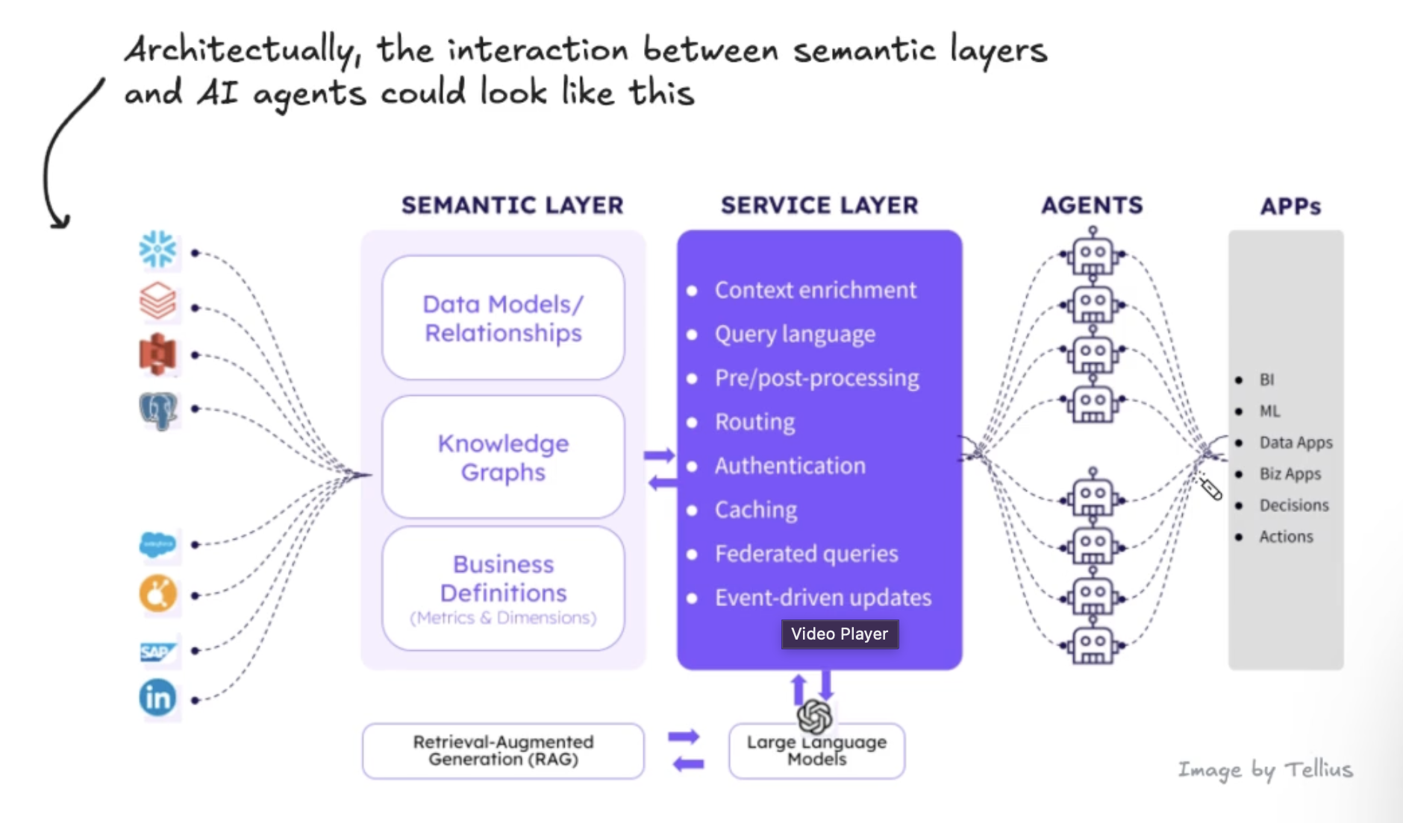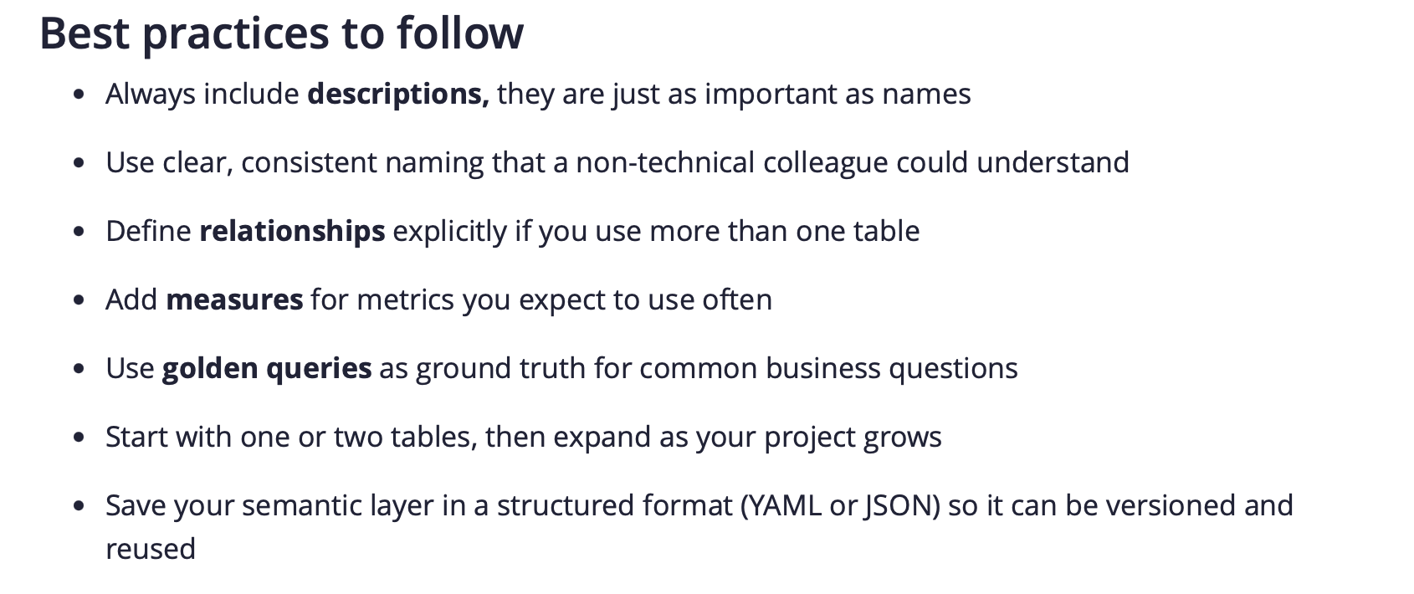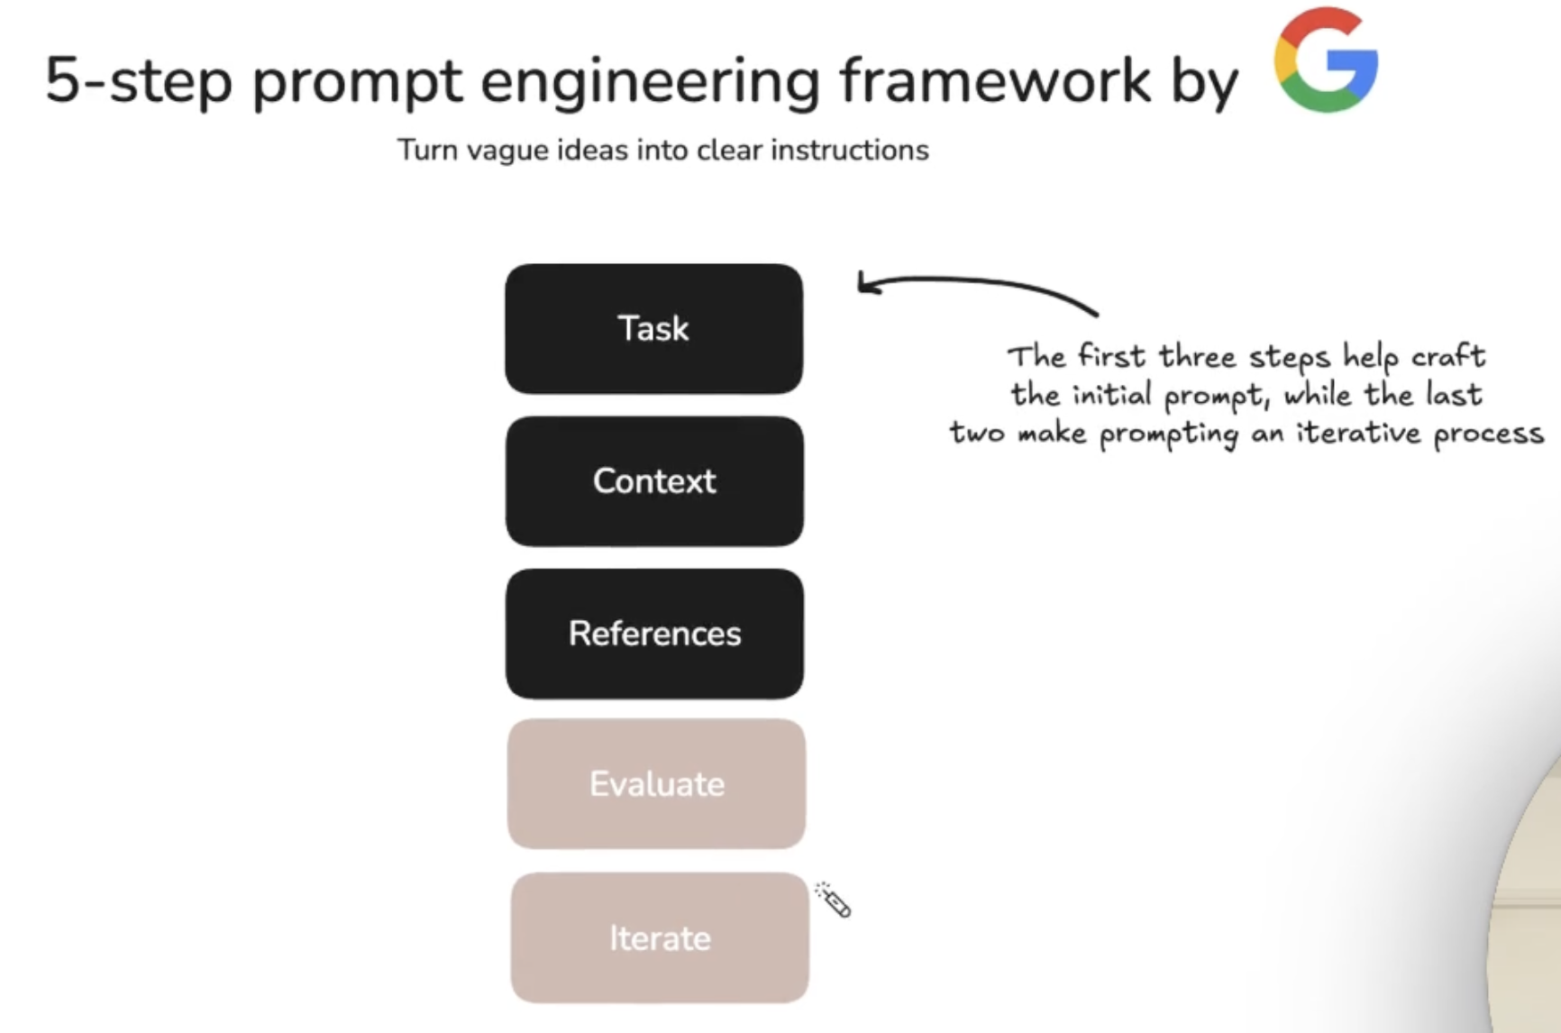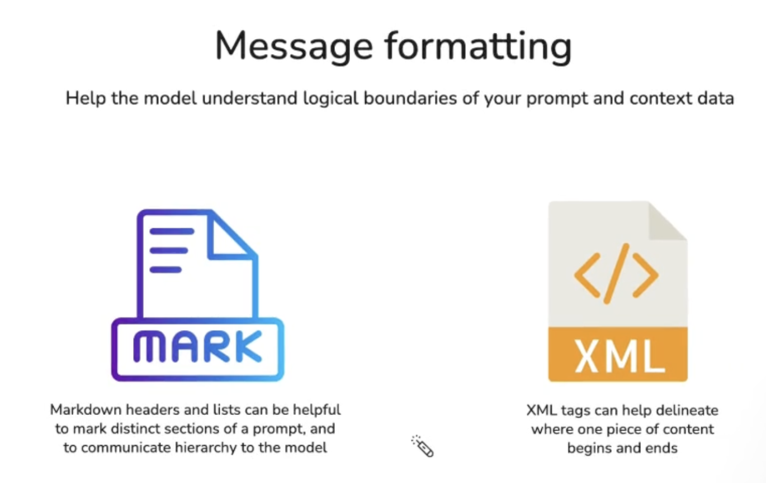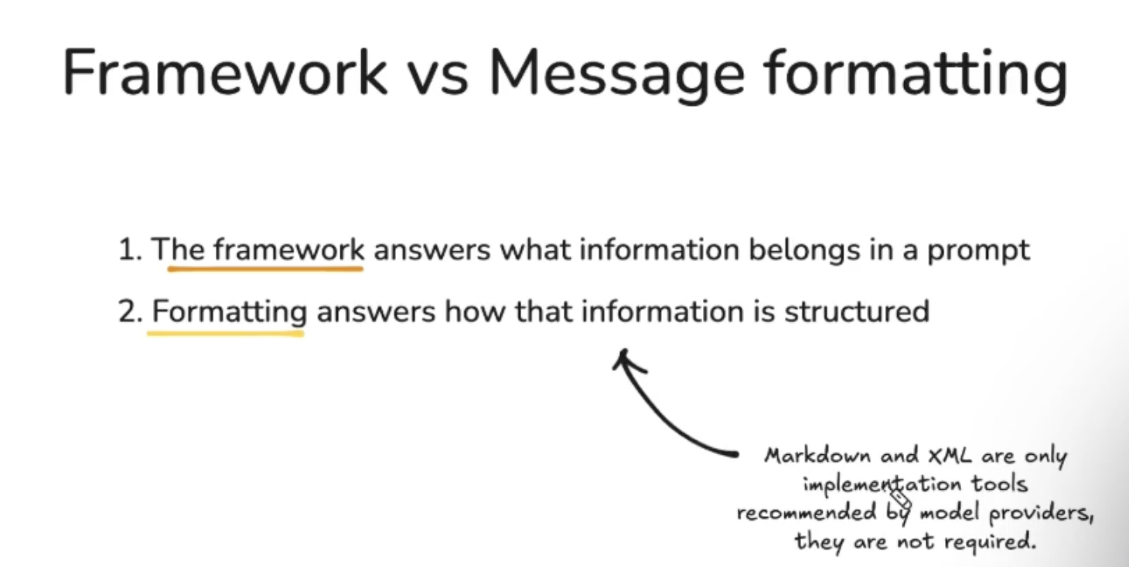

How Does a Semantic Layer Platform Work?
The semantic layer takes a business request and converts it into an optimal SQL query for your databases by implementing metrics, hierarchical relationships, and access rights automatically.
Here’s how it operates in practice:
- Connect to raw data sources: The semantic layer doesn’t require you to move/copy any of your data from your warehouses or data lakes. Instead, it simply queries each of the raw data systems in real-time when requested.
- Define business requirements and calculations: The team defines business requirements such as “what does revenue mean,” “how do we determine active customers,” etc., which includes defining facts (e.g., measurable values), dimensions (e.g., attributes such as regions), and hierarchies (e.g., taxonomies such as year > quarter > month).
- Implement governance/security and access rights: The semantic layer implements security and access control rights within its own framework, which then filters the data to the requesting users, and the permissions are carried over across all platforms and tools.
- Publish definitions to consuming applications: The semantic layer publishes definitions via standard interfaces (XMLA, JDBC, REST API, etc.) to allow consuming apps such as Power BI, Tableau, Python Notebooks, Excel, and AI systems to query in their native languages. It then optimizes the native application query into an SQL query that is sent to the database(s).
- Manage and monitor: When your data model changes, you only have to make one update to the semantic layer definition. All consuming applications will be updated, and you can also monitor metric usage and ensure consistency as additional tools are introduced.

What are the Business Benefits of a Semantic Layer?
The semantic layer maps business data into familiar business terms to offer a unified, consolidated view of data across the organization. The solution provides a single standard for consuming and driving enterprise-wide analytics. Benefits of a semantic layer include:
- Democratization of data analytics and machine learning (ML)
- Single source of truth
- Seamless model development and sharing
- Improved query performance and reduced computing costs
- Reduced data cleaning effort
- Better security and governance

1. Democratization of Data Analytics and ML
As data analytics spreads within organizations, relying on one monolithic BI or ML platform to meet everyone’s needs becomes less realistic. A semantic layer platform connects and works with diverse data platforms, protocols, and consumption tools, decoupling data from consumption and enabling democratization of analytics and ML.
Semantic layers make self-service and AI-assisted analytics safer by providing guardrails around what users and systems can access. Business analysts querying AI chatbots and citizen data scientists building models reference governed definitions instead of creating flawed interpretations.

2. Single Source of Truth
The semantic layer excels at creating sophisticated SQL in response to simplified user gestures. By applying rules to define database complexity and ambiguity, it guarantees that if two users ask for the same information, they get the same results.
This becomes critical when AI tools generate answers automatically. A semantic layer ensures AI-generated insights reference the same definitions that finance uses in official reports, maintaining trust even when humans are not writing the queries.

3. Seamless Model Development and Sharing
Data scientists rely on raw data for insights, but businesses need data models that create visual descriptions to help analyze and clarify relationships. The semantic layer enables easy authoring, sharing, and collaborating across analytics and AI workflows. BI analysts, data scientists, and AI developers can all reference the same metric definitions, reducing rework whether insights come from dashboards, Python notebooks, or AI-generated summaries.

4. Improved Query Performance and Reduced Computing Costs
While cloud computing offers scalability and flexibility, these benefits come at the expense of performance and costs. A good semantic layer platform includes comprehensive performance management beyond simple caching. It facilitates better query performance and time to insights while reducing computing costs by optimizing queries, leveraging aggregates, and managing data access efficiently.

5. Reduced Data Cleaning Effort
Studies show that over 70% of data analytics efforts go to data cleansing. A governance-enabled semantic layer ensures that analysts and data scientists have the same definitions and context for the data. Better-defined metrics reduce downstream confusion and rework. When everyone references the same calculations, teams stop reconciling conflicting dashboards, and AI systems stop generating summaries based on invented definitions.

6. Better Security and Governance
The semantic layer sits between the data platform and analytics tools, securing infrastructures with proper authentication and authorization. It supports single sign-on solutions and offers RBAC to protect sensitive data and limit access per business roles.
For AI governance, the semantic layer controls what AI systems can access and creates auditable trails. When AI agents query data or LLMs generate insights, the semantic layer enforces the same access controls that apply to human users while logging all activity for compliance.

Semantic Layers and AI
AI has fundamentally changed how your data gets accessed. Queries now run automatically, often without human oversight, as executives use generative AI to summarize quarterly performance or product managers use conversational BI to explore user behavior. Each interaction fires off database queries that need to land on the right definitions.
Without a semantic layer, AI tools become liability generators. They hallucinate metrics, misinterpret relationships, and produce confident answers built on flawed math. One AI assistant calculates monthly recurring revenue by summing invoices, another excludes trials, and finance uses a third method. Trust collapses.
Semantic layers make business logic machine-readable. AI systems query governed definitions using the same access controls, calculation rules, and hierarchies that BI tools do. When a sales VP asks an AI agent about regional growth, the semantic layer ensures official territory definitions and approved revenue logic get applied. The organization maintains control over what AI can say about the business, even as AI becomes the primary interface for data access.
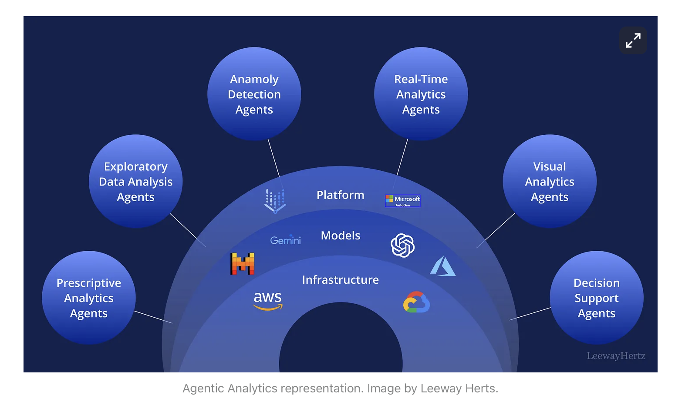
- What is a semantic layer?
- Semantic Layers and the Future of Agentic Analytics
- How to create a custom GPT
- AI prompt engineering: A deep dive
- How Gemini uses Looker’s semantic layer
- Google’s 68-Page Prompt Engineering Whitepaper (2025)
- Best practices for prompt engineering with OpenAI API
For your convenience, I have also created a NotebookLM notebook including all of these resources, give it a try here

